Problem solving with PCR
Story so far:
The nearby hospital has a severely sick patient. Doctors at the hospital were able to isolate a bacterium from the faecal sample of the patient. After sequencing the bacteria, you identified an unknown sequence. You used BLAST to identify a similar sequence in the database. This sequence was identified as belonging to E. coli. After taking the patients history you realise that this person really likes to swim and has recently been to three public beaches.
You hypothesise that this patient was contaminated at the beach. This constitutes as a hazard to human health. Potentially, more people may become infected with this strain of E.coli. You designed primers to amplify this previously unknown DNA sequence and now you want to figure out which of the beaches could be hazardous to the public. If you know this, you can act – for example close public access to the beach and improving the water quality by identifying sources of contamination (e.g. wastewater leaks).
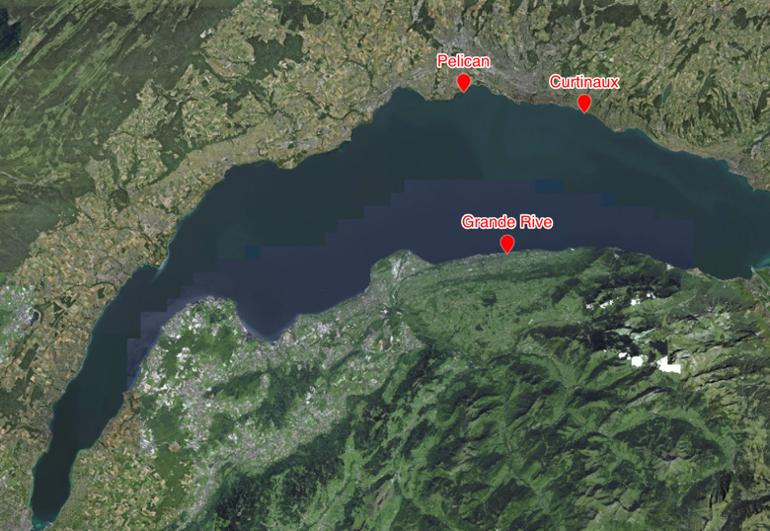
The beaches are:
Beach A: Plage de Curtinaux – Lutry, Switzerland
Beach B: Plage du Pélican – Saint Sulpice, Switzerland
Beach C: Plage de Grande Rive – Évian-les-Bains, France
Using primers that you have developed; you decide to do an experiment using PCR to see if the target sequence is in any of the lake samples.
- What is/are your variable(s)?

- What can potentially be used as a control?

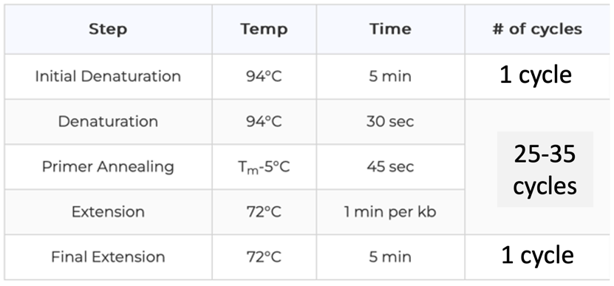
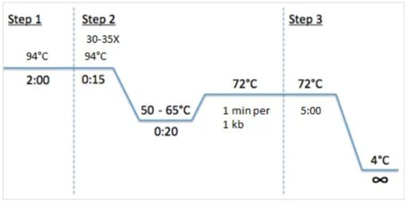
This is a typical PCR program:

- Why do you think Step 1 (initial denaturation) is longer than the denaturations in Step 2?

- Design the PCR program you will use with your primers and write out the steps:

- What additional positive or negative controls do you think you need and can use?

You do your PCR and now check results on a gel electrophoreses:
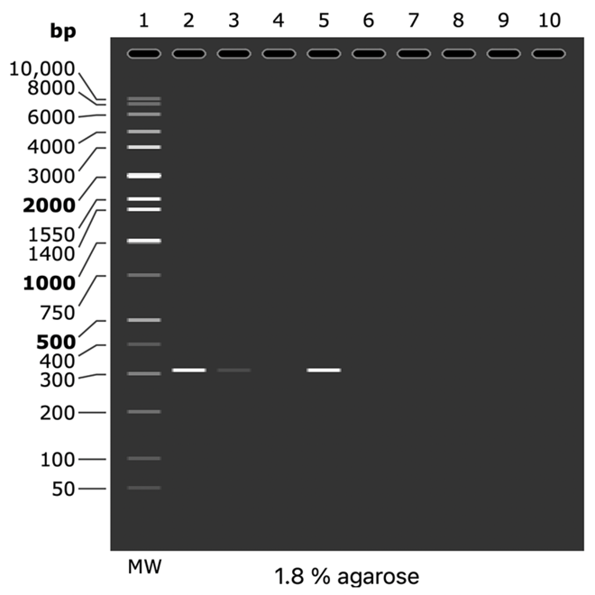
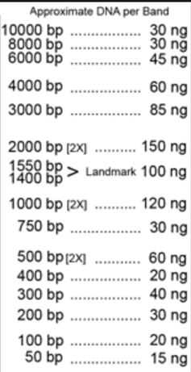
Lane 1: Molecular weight (MW) ladder
Lane 2: Beach A
Lane 3: Beach B
Lane 4: Beach C
Lane 5: +ve control (what can you use for this)?
Lane 6: -ve control (what can you use for this)?

- What conclusions can you make if this is your result? Where is the contamination likely originating from?

- If you stared with 7 fragments of your target gene in the lake sample, how many do you expect if your PCR program has 30 cycles of PCR? What if you started with less or more DNA?

- What if you had these results instead? (same lanes as above)
How would you interpret the results in each case?
A B C D
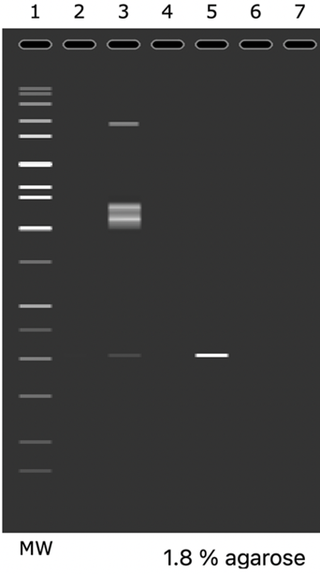
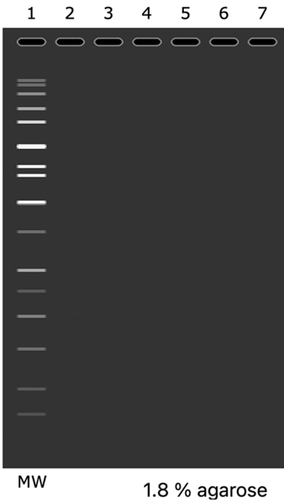
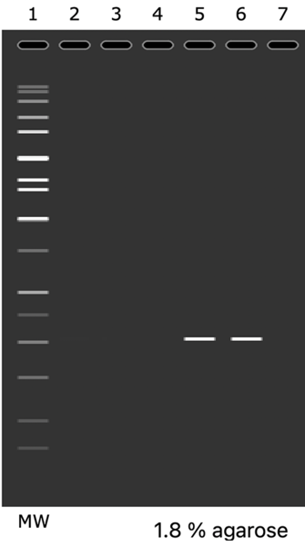
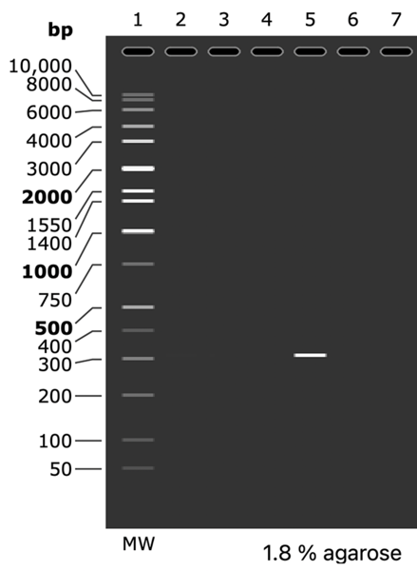

Here is a realistic gel from another experiment:
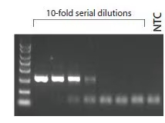
- What do you think those small DNA fragments at the bottom of the gel could be?

Sometimes there are contaminants in environmental samples (water, soil) that can inhibit the PCR reaction (usually inhibiting the taq polymerase).
- Consider gel A (from question 8). Would you be able to tell the difference between:
i) none of the beaches are contaminated with bacteria that has this “unknown” gene
ii) the environmental sample had contaminants in it that inhibited the PCR reaction

- Could you suggest a control(s) to differentiate between these scenarios?

